Project Proposal

Project Title

CampusGPT: An AI-Powered University Information and Student Support Assistant Using Retrieval-Augmented Generation (RAG)

1. Introduction
Higher education institutions generate and manage a large amount of academic and administrative information every semester. Students regularly need access to faculty contact details, class schedules, examination routines, office locations, academic calendars, notices, application forms, and university procedures. However, this information is often scattered across multiple websites, departmental offices, notice boards, and social media platforms. Consequently, students spend considerable time searching for information or visiting university offices for simple queries, increasing both student frustration and administrative workload.
To address this challenge, this project proposes the development of CampusGPT, an AI-powered university information assistant that functions similarly to ChatGPT but is specifically designed to answer university-related questions only.
Unlike general AI chatbots that rely on internet knowledge, CampusGPT will implement Retrieval-Augmented Generation (RAG), allowing the AI to retrieve information directly from the university's verified knowledge base before generating responses. This approach ensures that answers remain accurate, relevant, and based on official university information.
The proposed system will provide a modern conversational interface where students can instantly retrieve university information in both English and Bangla, while administrators can easily update the knowledge base through an admin dashboard.

2. Problem Statement
Students frequently experience difficulties obtaining official university information due to several existing challenges:
- University information is distributed across multiple websites, departments, and notice boards.
- Students often wait in long queues for simple administrative inquiries.
- Faculty members repeatedly answer the same questions from different students.
- Finding official application forms and procedures is time-consuming.
- There is no centralized intelligent system that provides university-specific information.
- Existing search systems require students to know exactly where information is stored.
These issues reduce administrative efficiency and negatively affect the overall student experience.

3. Aim of the Project
The aim of this project is to develop an AI-powered university assistant that enables students to obtain official university information quickly through natural language conversations using Retrieval-Augmented Generation (RAG).

4. Objectives

General Objective
To design and develop an AI-based university information assistant capable of providing accurate, context-aware, and university-specific responses.

Specific Objectives
- Develop an intelligent conversational chatbot exclusively for university-related information.
- Implement Retrieval-Augmented Generation (RAG) to improve response accuracy.
- Create a centralized university knowledge base.
- Provide faculty information including email, office room, department, designation, and contact details.
- Display class routines and examination schedules.
- Search academic notices and announcements.
- Provide office locations and contact information.
- Offer downloadable application templates.
- Support English and Bangla conversations.
- Develop a secure administrator dashboard for knowledge management.
- Implement secure Email and Password Authentication.
- Maintain user chat history for future reference.

5. Scope of the Project
The system will cover various university services including:
- Faculty Information
- Class Routine
- Examination Schedule
- Academic Calendar
- Office Directory
- Notice Search
- University Policies
- Application Templates
- Frequently Asked Questions
- Campus Navigation
- Student Support
- Chat History
- Multilingual Communication
The chatbot will only answer questions related to the university and will avoid responding to unrelated general knowledge questions.

6. Proposed Solution
CampusGPT is an AI-powered conversational assistant that combines modern Large Language Models (LLMs) with Retrieval-Augmented Generation (RAG).
The system stores university information inside MongoDB and converts uploaded documents into vector embeddings stored in ChromaDB. Whenever a student asks a question, the system retrieves the most relevant information from the vector database and passes it to the AI model to generate an accurate and context-aware response.
This retrieval process minimizes hallucination and ensures responses are based on official university documents rather than the model's general knowledge.
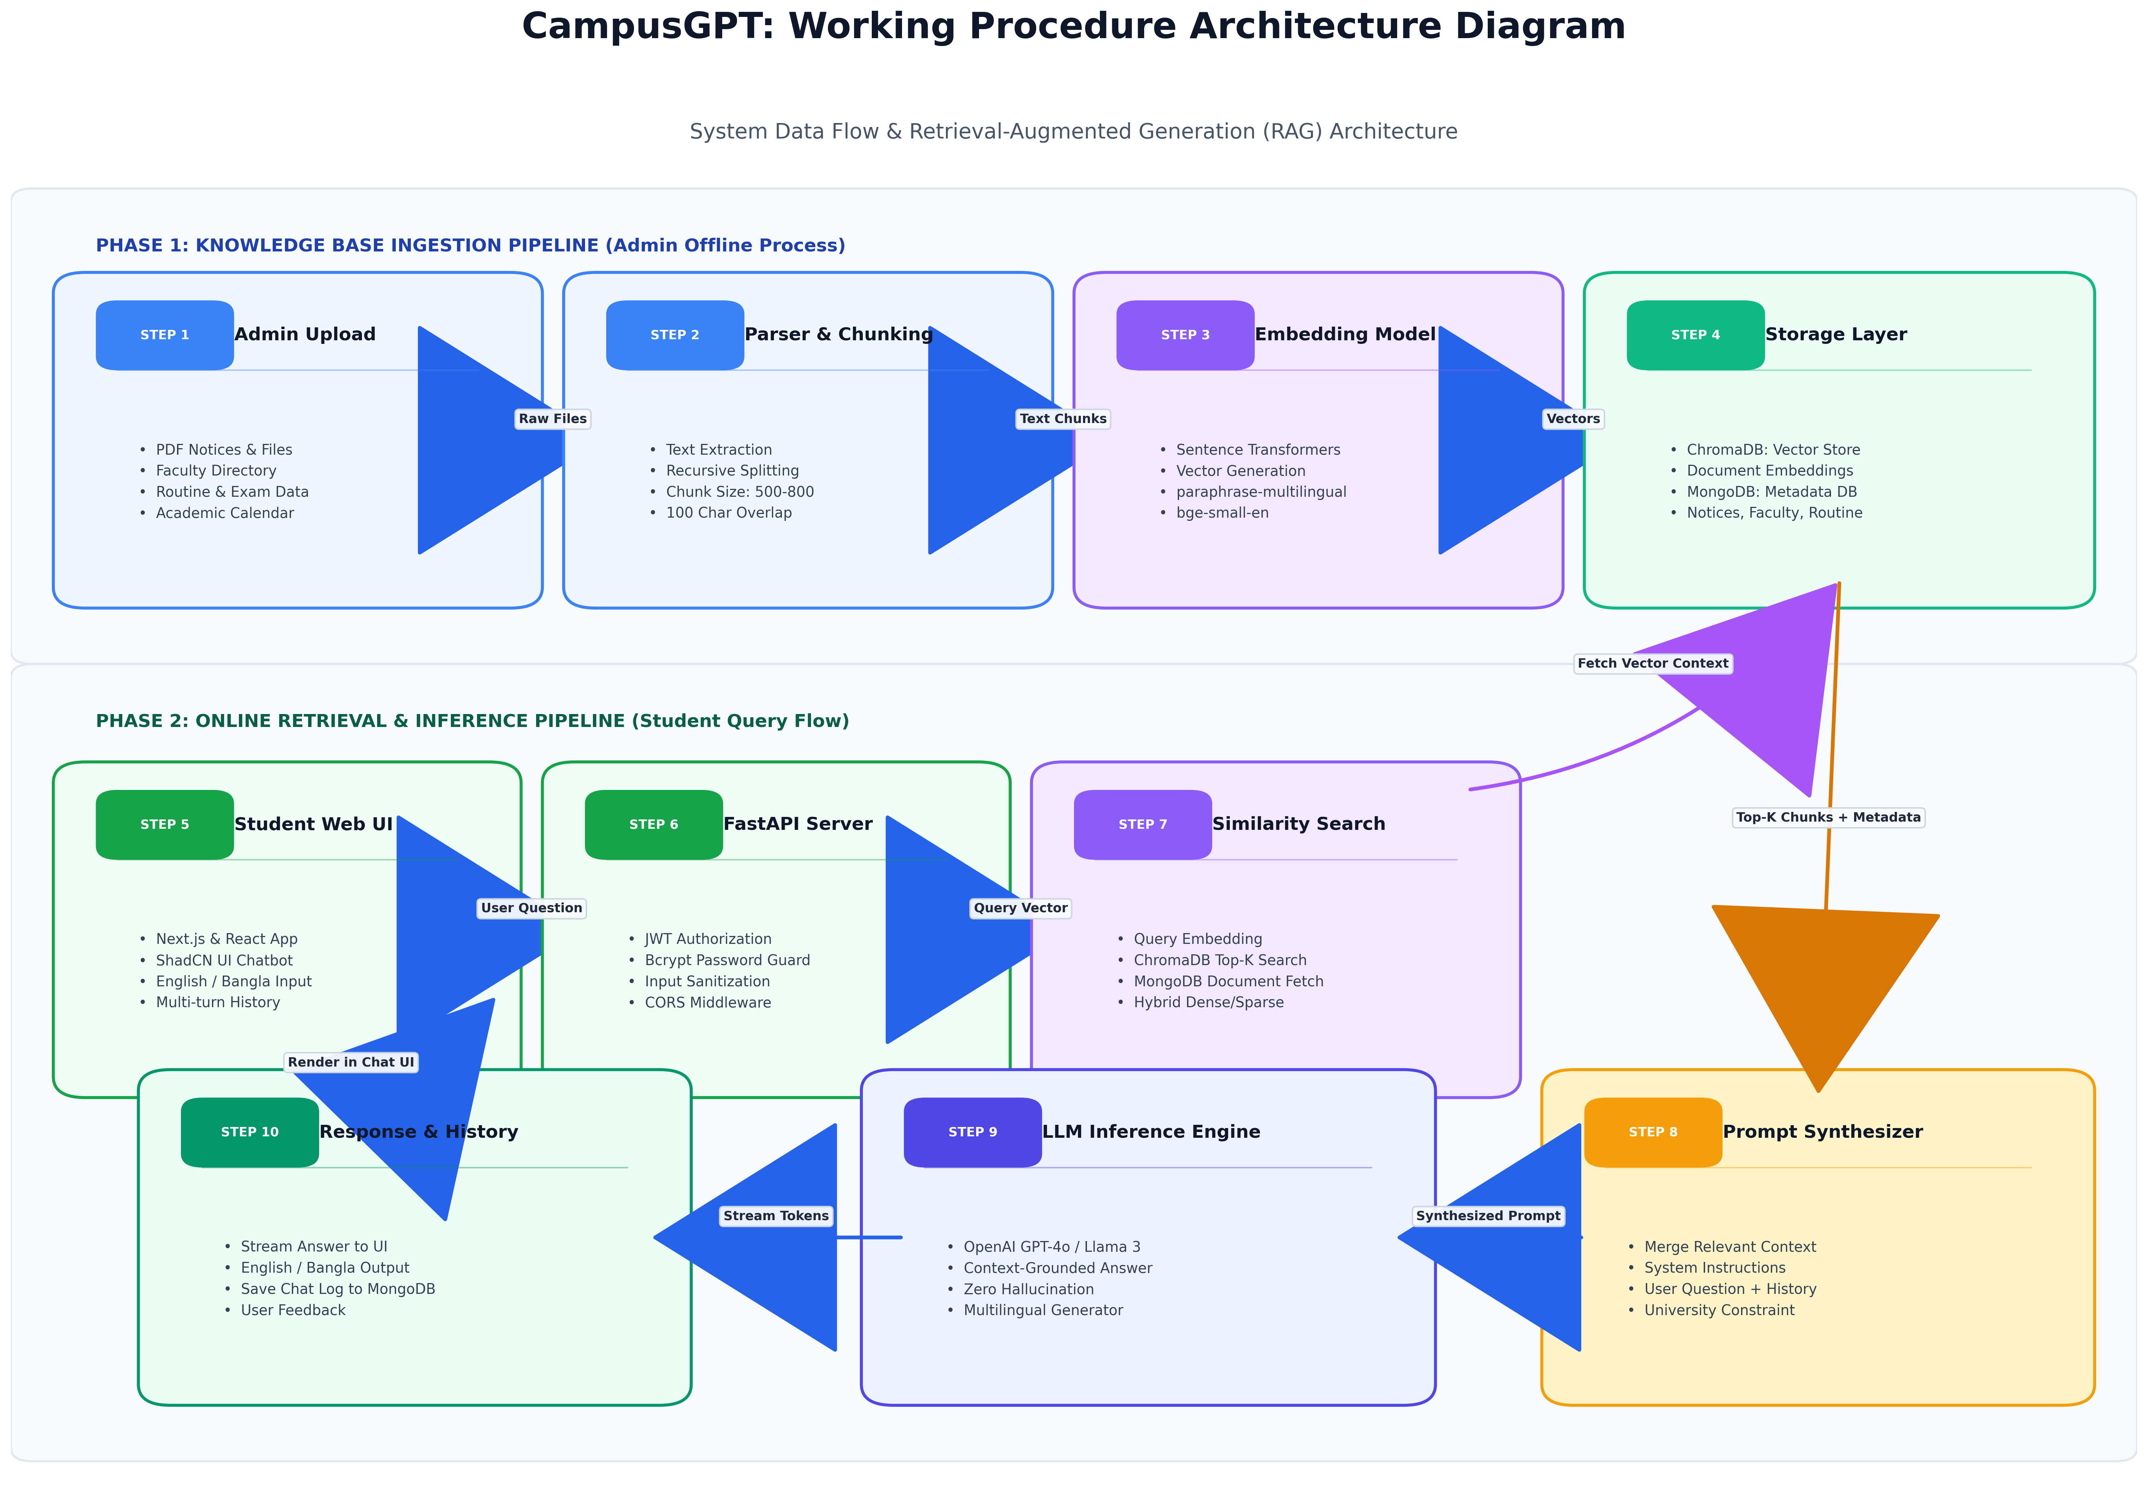
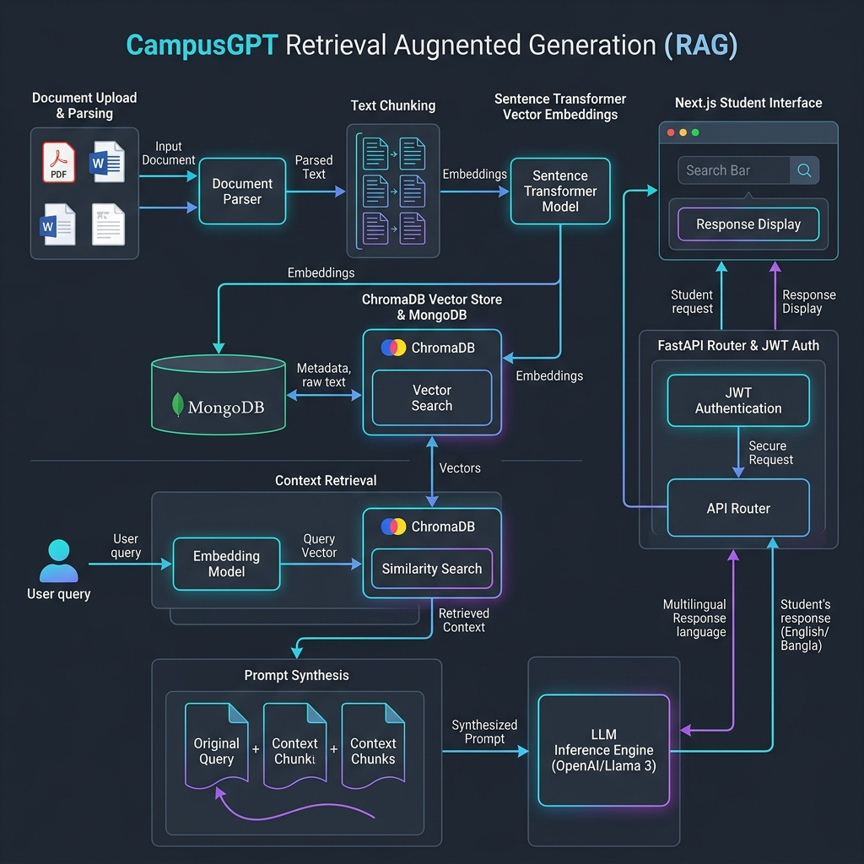

7. Functional Requirements

7.1 Student Module
Students can:
- Register using Email and Password
- Login securely
- Ask university-related questions
- Search faculty information
- View class routines
- View examination schedules
- Search notices
- Access academic calendar
- Download application templates
- View office information
- Find campus locations
- View previous chat history
- Switch between English and Bangla

7.2 Administrator Module
Administrators can:
- Login securely
- Manage faculty information
- Upload notices
- Upload PDF documents
- Upload application templates
- Manage class routines
- Manage examination schedules
- Manage office directory
- Manage academic calendar
- Manage FAQs
- Manage users
- Update knowledge base
- Rebuild vector embeddings after document updates

8. Non-Functional Requirements
- Fast response time
- High availability
- Secure authentication
- User-friendly interface
- Scalable architecture
- Accurate AI responses
- Mobile responsive design
- Secure password encryption
- Easy maintenance
- Extensible architecture

9. System Features

9.1 AI Chatbot
- ChatGPT-like interface
- Natural language understanding
- Context-aware responses
- University-specific answers
- Multi-turn conversations

9.2 Faculty Information
Students can search:
- Faculty Name
- Department
- Designation
- Email
- Phone Number
- Office Room
- Office Hours

9.3 Office Directory
Search information for:
- Registrar Office
- Accounts Office
- Library
- Administration Office
- Medical Centre
- Super Shop
- Laboratories
- Transport Office
Including:
- Office Location
- Contact Number
- Email
- Office Hours
- Google Maps Link

9.4 Class Routine
Students can search using:
- Department
- Semester
- Section
The chatbot returns:
- Course Name
- Instructor
- Room Number
- Time
- Day

9.5 Examination Schedule
Students can retrieve:
- Exam Date
- Course Code
- Course Name
- Time
- Venue

9.6 Academic Calendar
Students can ask about:
- Semester Start
- Registration
- Holidays
- Mid-Term Exams
- Final Exams
- Convocation

9.7 Notice Search
Students can search uploaded university notices using natural language.
Example:
"Show notices about internship."

9.8 Application Templates
Students can download:
- Leave Application
- Transcript Request
- Semester Freeze
- Course Withdrawal
- Recommendation Request
- Financial Support Application

9.9 Campus Navigation
Search:
- Buildings
- Departments
- Classrooms
- Laboratories
- Offices
Including Google Maps links.

9.10 Student Support
Students can ask:
- Registration procedure
- Semester withdrawal
- Course add/drop
- Scholarship information
- Graduation requirements
- Credit transfer
- Thesis guidelines

9.11 Chat History
Users can:
- View previous chats
- Continue conversations
- Delete chat history

9.12 Multilingual Support
Supported Languages:
- English
- Bangla

10. Methodology
The project follows the Retrieval-Augmented Generation (RAG) workflow.

Step 1
Collect university data from:
- Faculty Directory
- Office Information
- Academic Calendar
- Notices
- University Website
- PDF Documents

Step 2
Store structured data in MongoDB.

Step 3
Upload PDF documents.

Step 4
Split documents into text chunks.

Step 5
Generate embeddings using Sentence Transformers.

Step 6
Store embeddings in ChromaDB.

Step 7
Receive user query.

Step 8
Retrieve relevant document chunks.

Step 9
Send retrieved context to the LLM.

Step 10
Generate AI response.

Step 11
Display response to the user.

11. System Architecture
Student
│
▼
Next.js Frontend
│
▼
JWT Authentication API
│
▼
FastAPI Backend
│
┌───────────┴───────────┐
│ │
▼ ▼
MongoDB ChromaDB
(User, Faculty, Notices) (Vector Embeddings)
│ │
└───────────┬───────────┘
▼
RAG Pipeline
│
▼
Large Language Model
(OpenAI GPT / Llama 3 / Qwen)
│
▼
AI Response

12. Database Design

Collections

Users
- _id
- name
- email
- password (hashed using bcrypt)
- role
- createdAt

Faculty
- name
- department
- designation
- email
- phone
- officeRoom
- officeHours

Notices
- title
- description
- file
- uploadDate

Office
- officeName
- location
- phone
- email
- officeHours

ClassRoutine
- department
- semester
- section
- course
- instructor
- room
- day
- time

ExamRoutine
- course
- date
- venue
- time

AcademicCalendar
- event
- startDate
- endDate

Documents
- title
- filePath
- embeddingStatus

ChatHistory
- userId
- question
- answer
- timestamp

13. Technology Stack

Frontend
- Next.js
- React.js
- TypeScript
- Tailwind CSS
- ShadCN UI

Backend
- FastAPI (Python)

Database
- MongoDB

Vector Database
- ChromaDB

AI & RAG
- LangChain
- Sentence Transformers
- ChromaDB
- OpenAI GPT API / Llama 3 / Qwen

Authentication
- Email & Password Authentication
- JWT (JSON Web Token)
- Bcrypt Password Hashing

File Storage
- Cloudinary

14. Security Features
The system incorporates several security measures:
- Email and Password authentication
- Password hashing using Bcrypt
- JWT-based authorization
- Role-Based Access Control (RBAC)
- Protected Admin Routes
- Input validation
- Secure API endpoints
- Environment variables for sensitive credentials
- CORS protection

15. Expected Outcomes
The proposed system is expected to:
- Reduce the time required to access university information.
- Improve communication between students and administration.
- Reduce repetitive inquiries handled by university staff.
- Increase student satisfaction.
- Provide a centralized digital knowledge platform.
- Demonstrate practical implementation of Artificial Intelligence in higher education.
- Improve administrative efficiency through intelligent automation.

16. Future Enhancements
Future versions of CampusGPT may include:
- Voice Assistant
- Mobile Application (Android & iOS)
- Attendance Information
- Student Result Checking
- Fee Payment Status
- Bus Tracking
- Lost & Found Module
- Event Recommendation System
- AI Course Recommendation
- AI Career Advisor
- WhatsApp Integration
- Telegram Bot
- Appointment Booking System
- Student Portal Integration
- Push Notifications
- OCR-based Document Reading

17. Advantages of the Proposed System
- Centralized university information
- AI-powered intelligent search
- Faster response than manual inquiries
- Reduced administrative workload
- Accurate answers using RAG
- Modern conversational interface
- Supports multiple languages
- Easy maintenance through admin dashboard
- Scalable for future university services

18. Limitations
- The chatbot only answers questions based on available university data.
- AI responses depend on the quality of the uploaded knowledge base.
- Internet connectivity is required.
- Initial setup of the knowledge base requires administrative effort.
- Local LLM deployment may require higher hardware resources.

19. Conclusion
CampusGPT is an intelligent AI-powered university information and student support system designed to transform the way students interact with university services. By integrating Retrieval-Augmented Generation (RAG), Large Language Models (LLMs), MongoDB, ChromaDB, and a secure authentication system based on Email, Password, JWT, and Bcrypt, the proposed solution delivers accurate, reliable, and context-aware responses using verified university information.
The system provides a centralized platform where students can access faculty details, class routines, examination schedules, notices, office information, application templates, and academic guidance through a natural conversational interface in both English and Bangla. Administrators can efficiently manage the university knowledge base through a dedicated dashboard, ensuring that the information remains current and accurate.
Overall, CampusGPT demonstrates the practical application of Artificial Intelligence in higher education by improving information accessibility, reducing administrative workload, and enhancing the overall student experience. With its scalable architecture and future expansion possibilities, the system has strong potential to serve as an official AI-powered digital assistant for universities.

